**Classic load balancers:**

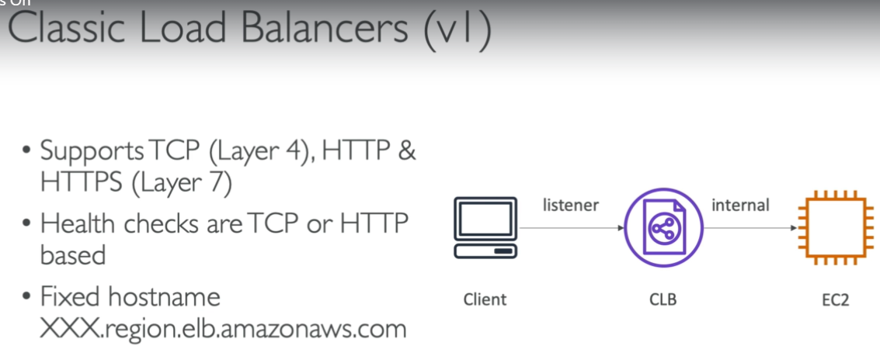

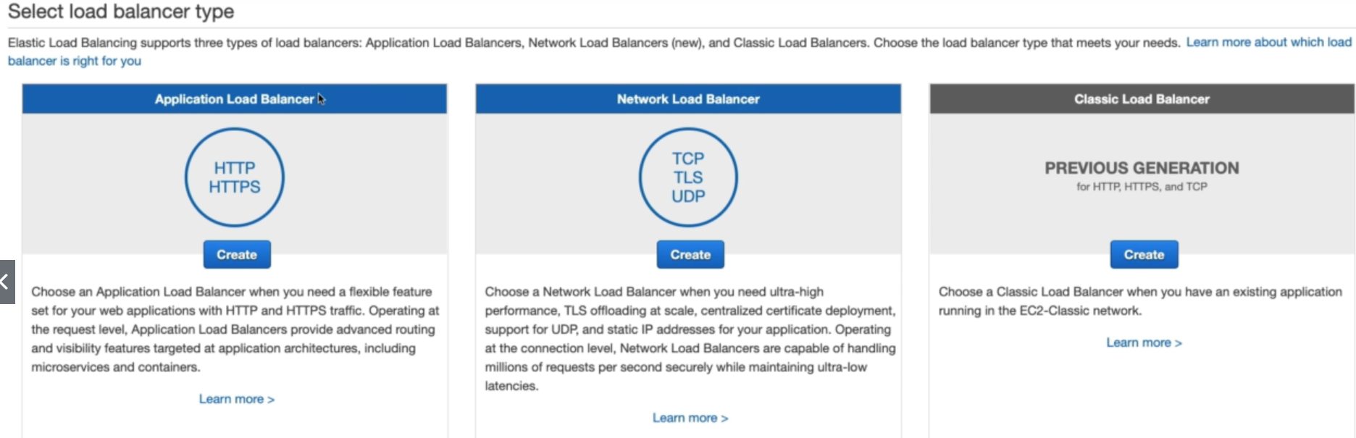

**Creating CLB:**

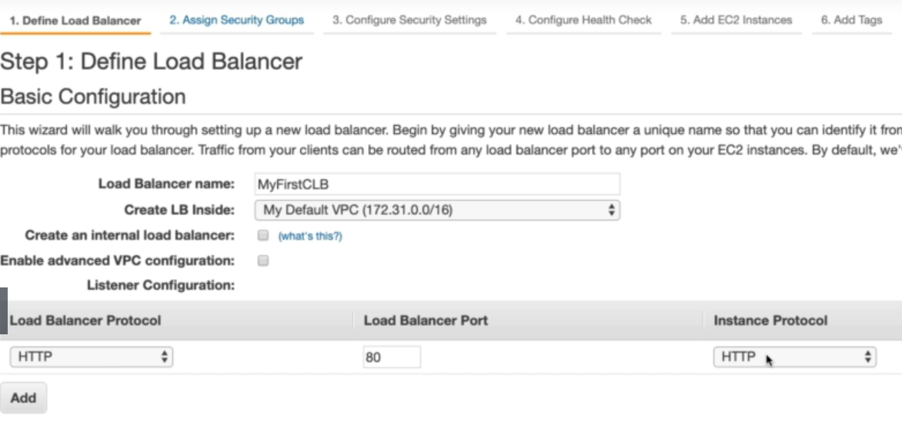

* While creating a classic load balancer, give it a name, select the VPC and the port for load balancer as above.
* If we select the option to **“create an internal load balancer”**. Then it will have only private IP address. If we keep it unchecked, then LB will have public IP and can be accessed from internet.

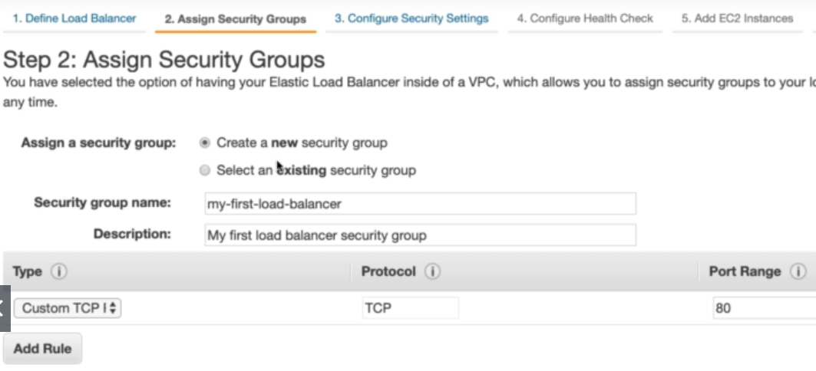

* **Next step is to create or assign the existing security group to load balancer**

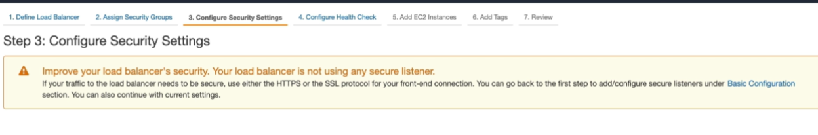

* Next step is for security settings to HTTPS.
* We get the above warning as we didn’t choose HTTPS protocol in earlier step. We need to use SSL protocol for HTTPS request

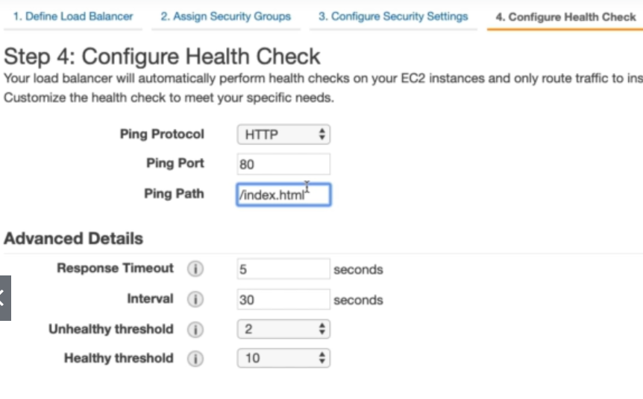

* Next step is to enable health check to ping the server and checks. We can give index.html path to check or if we can able to reach with just “/”. We can give that also.

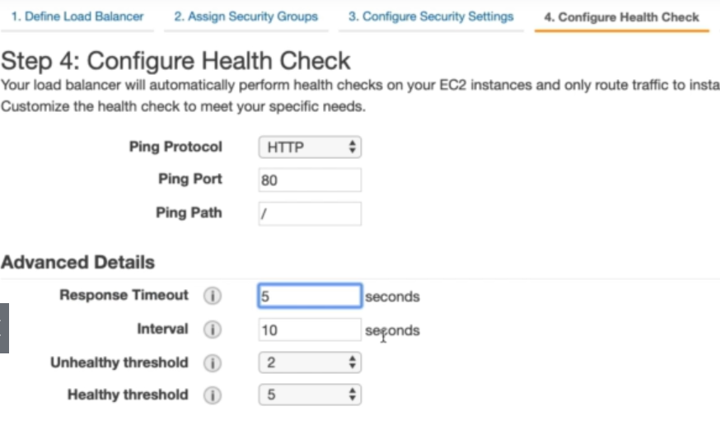

* We can also add the advanced details as above
* Response timeout means after how much time it should wait to get the response from the server.
* Internal means the time of intervals to do the health checks
* Unhealth or health threshold means the load balancer with treat a server as health or unhealthy after the threshold time of responses.
* Interval should be more than response timeout. Otherwise, it may fail to create the load balancer.
* If we reduce the interval time, it may increase the load on the server

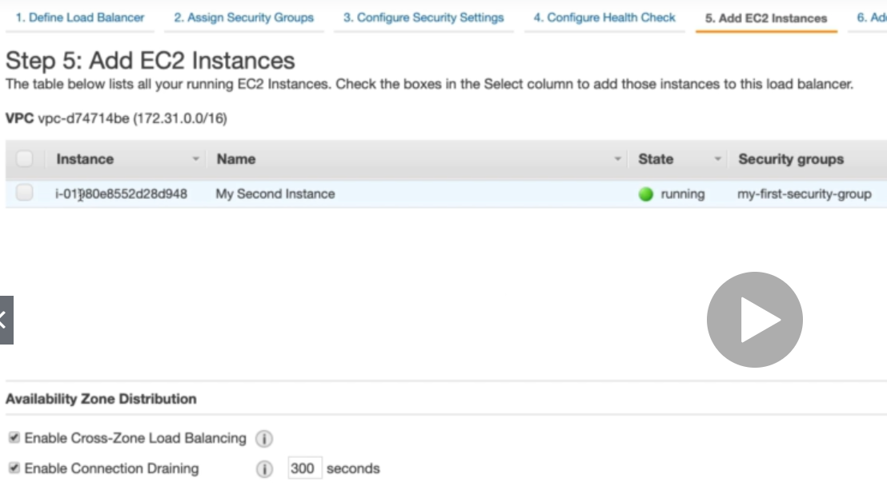

* Next step, we add the EC2 instances required for load balancing.
* Then finally, add tags, review the configuration and create the load balancer.

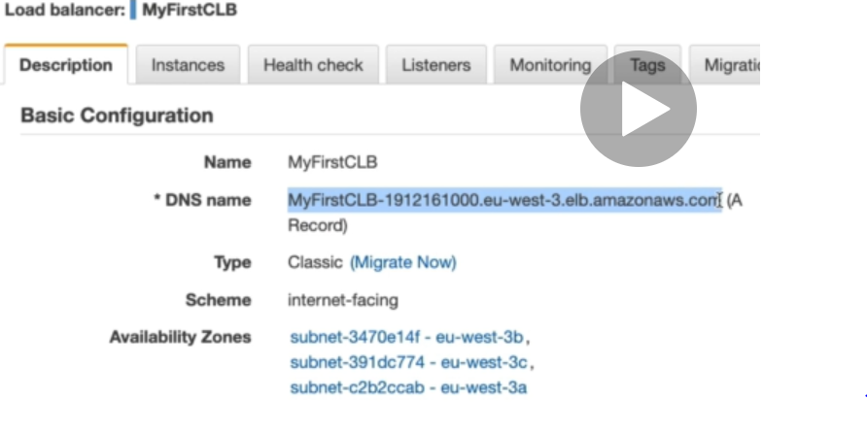

* Now, we can use the DNS name of load balancer and will get the same response as we get from the server with IP.
* ELB will keep pinging the servers for the response as we mentioned in health checks. If any of the server is unhealthy. Then it won’t send the requests to those servers.

**ELB cannot load balance to other VPC or to another region**

**Security groups:**

* To make the above connection happen. We need to the below security groups enabled on load balancer and on the server.

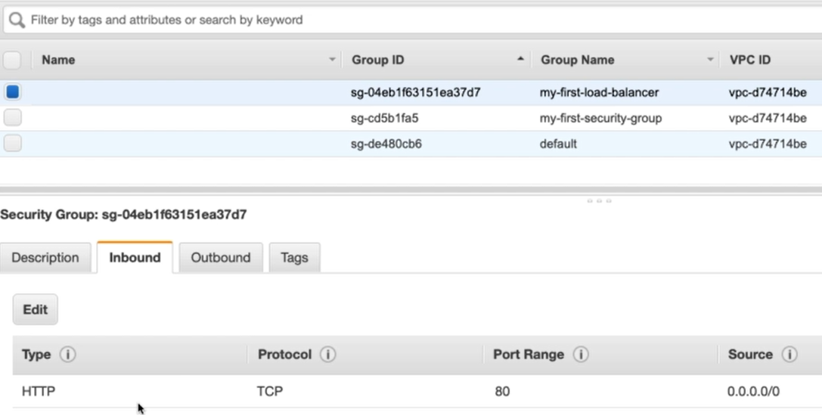

* We can see pot 80 in enabled an inbound rule in load balancer.

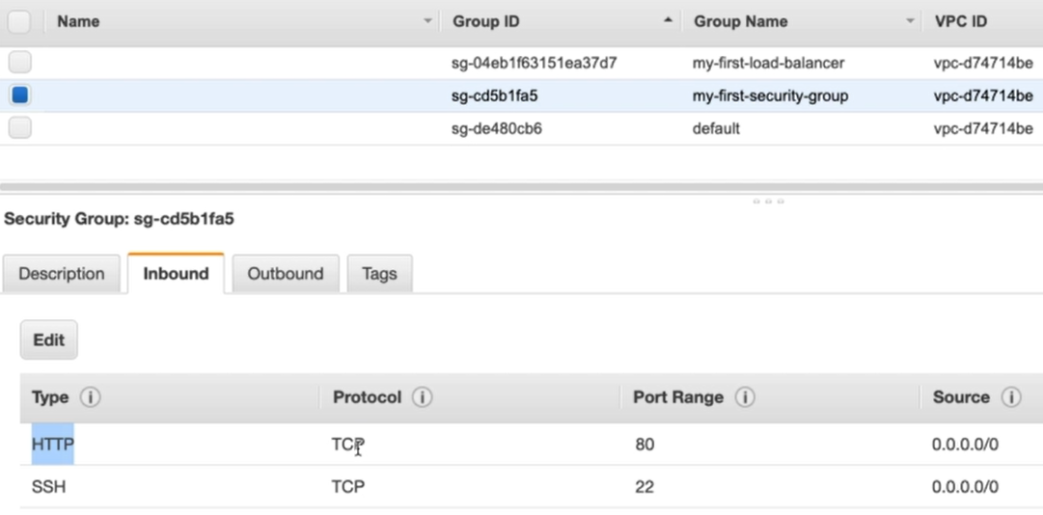

* The same is enabled in server security group as well.

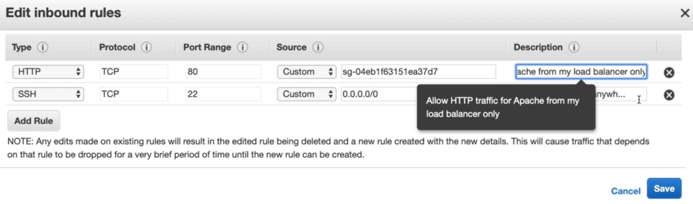

* We can also change to enable the connection only from the load balancer by giving the load balancer’s security group as above.

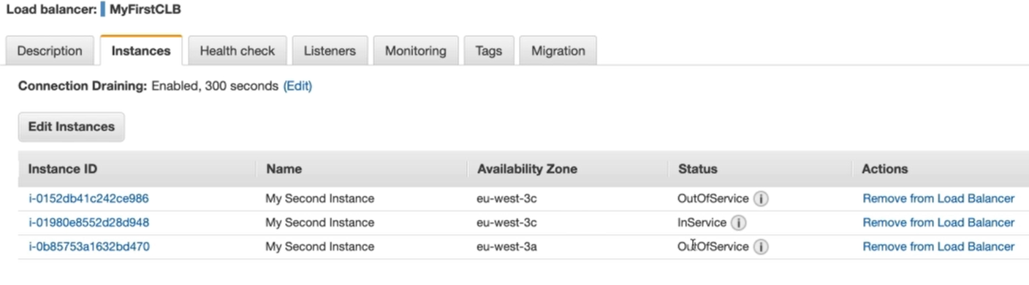

* We can also create the servers from different availability zones and add them to a load balancer as above to keep the application high availability.